Technical Documentation
Live-Rate Jewellery Configurator, Cart & Checkout
22 October 2026
Contents

How the Live-Rate Jewellery Configurator works: architecture, flows, data model, and every API endpoint.

1. Architecture
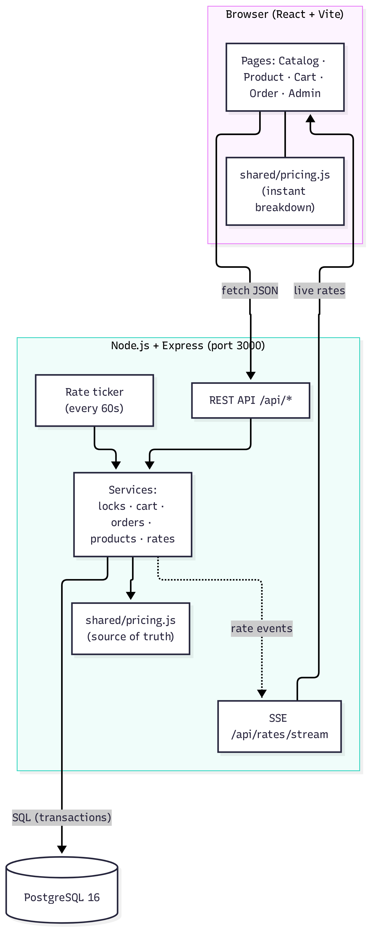
Layer | Technology | Responsibility
Client | React 18, React Router, Vite | Configurator, cart, countdowns, live-rate display
Shared | Plain JavaScript module | Pricing engine used by both client and server
Server | Node 22, Express 4, pg | API, price locks, re-pricing, checkout, rate ticker, SSE
Database | PostgreSQL 16 | Products, rates, locks, carts, orders; row-level locking for safe checkout
Packaging | Docker Compose | db, app and test services; one command to run
Key design decision: the same shared/pricing.js runs in the browser and on the server. The browser uses it to update the breakdown instantly as the customer changes options. The server uses it to decide what to charge, and never trusts a price sent by the browser. The browser's number is only used as a check: if it differs from the server's, the request is refused.

2. Price calculation
File: shared/pricing.js

Units (all integers, no floating point)
Quantity | Unit | Example
Money | paise | ₹12,450.00 → 1245000
Weight | milligrams | 4.200 g → 4200
Percentages | basis points | 10% → 1000, 3% → 300
Purity | fineness (parts per 1000) | 22K → 916

Formula
purityRate = round( baseRate999 × fineness / 999 ) paise per gram
metal = round( purityRate × weightMg / 1000 )
wastage = round( metal × wastageBps / 10000 )
making = per_gram : round( makingValue × weightMg / 1000 )
percent : round( metal × makingValue / 10000 )
flat : makingValue
stones = Σ pricePaise × count
subtotal = metal + wastage + making + stones
gst = round( subtotal × 300 / 10000 )
total = subtotal + gst
round is half-up to the nearest paisa, done with BigInt (roundDiv).

Worked example (seeded Aarna Solitaire Ring, 22K, size 12, gold at ₹12,450/g)
Line | Working | Amount
22K rate | 12,450 × 916 ÷ 999 = 11,415.6156 | ₹11,415.62 /g
Metal | 11,415.62 × 4.200 g = 47,945.604 | ₹47,945.60
Wastage | 10% of metal | ₹4,794.56
Making | ₹650 × 4.2 g | ₹2,730.00
Stones | ₹38,500 + 2 × ₹450 | ₹39,400.00
Subtotal |  | ₹94,870.16
GST | 3% = 2,846.1048 | ₹2,846.10
Total |  | ₹97,716.26

Exported functions
Function | Purpose
calculatePrice({ baseRatePaise999, fineness, weightMg, wastageBps, making, stones }) | Core calculation; returns every line
priceProduct(product, { purityCode, sizeCode }, baseRatePaise999) | Price a product configuration; adds labels for display
purityRatePerGram(baseRate, fineness) | Rate for a given purity
roundDiv(n, d) | Half-up integer division
formatINR, formatGrams, formatBps | Display helpers
GST_BPS, LOCK_MS | Constants (3%, 10 minutes)

3. Flow diagrams

3.1 Viewing a product and configuring it
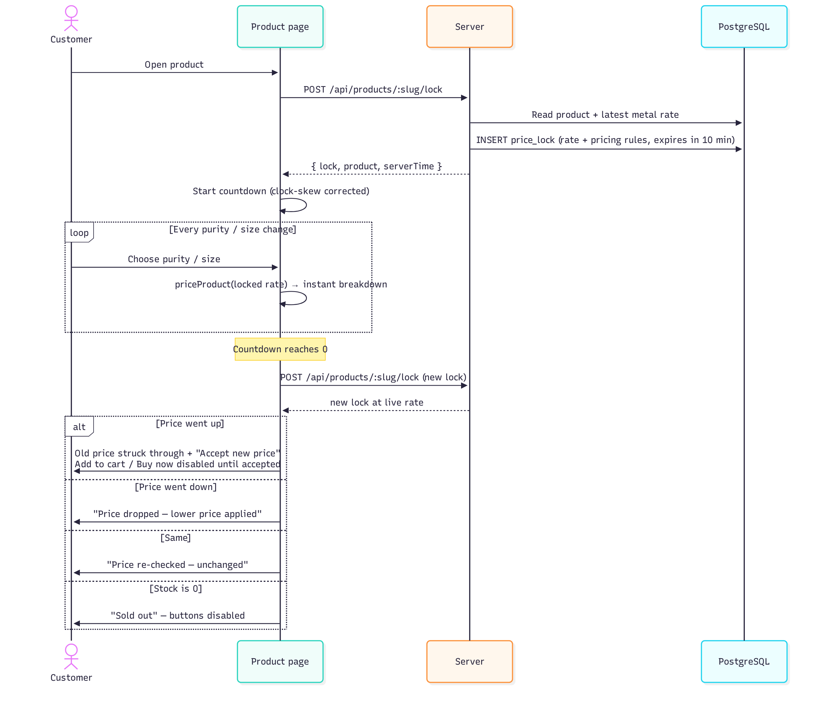

3.2 Add to cart
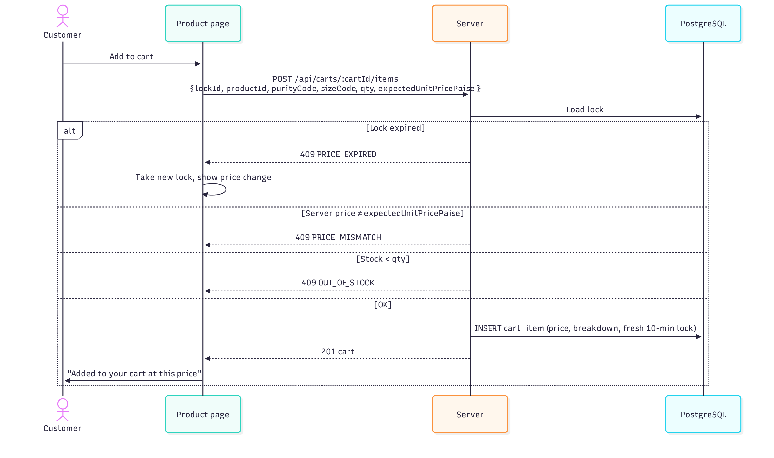

3.3 Cart re-pricing after a lock expires
Every GET /api/carts/:cartId re-checks each item in one transaction.
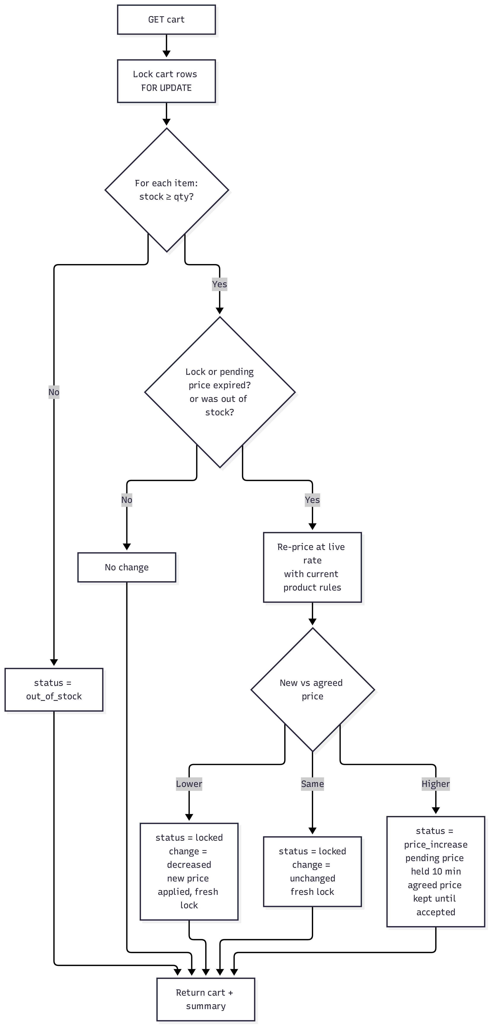

3.4 Checkout (cart)
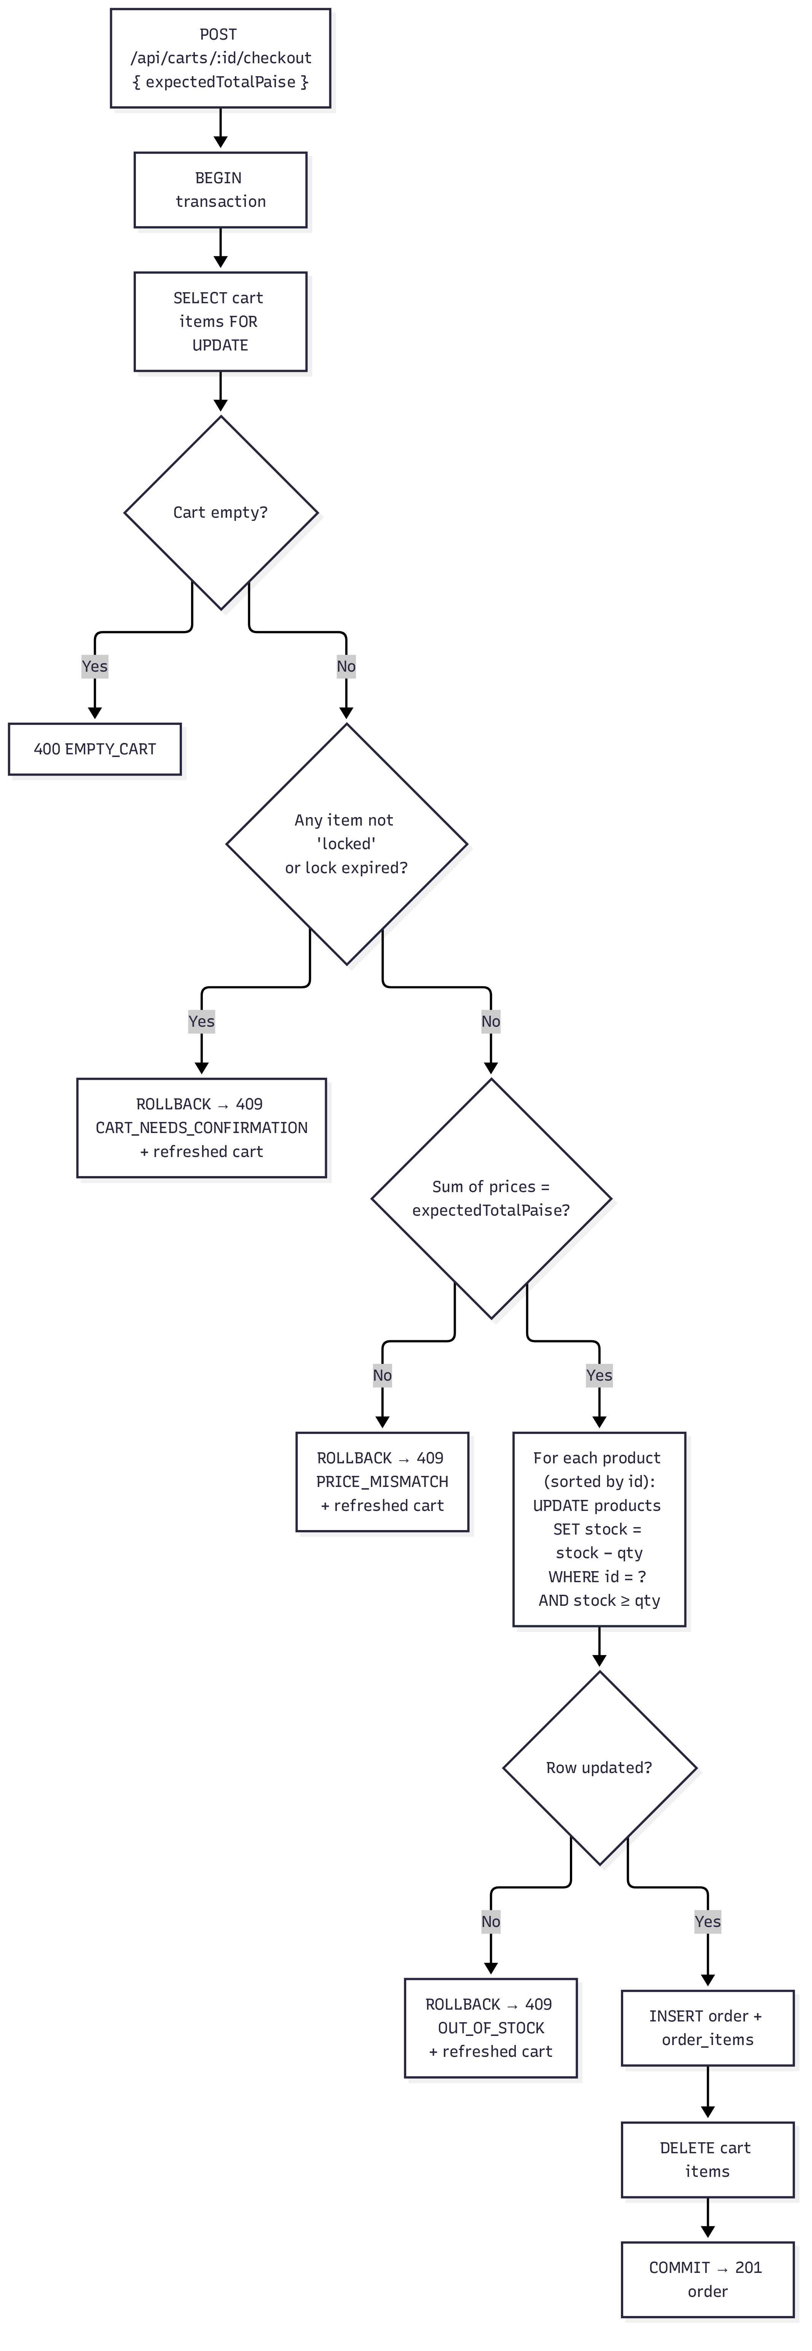

3.5 Buy now
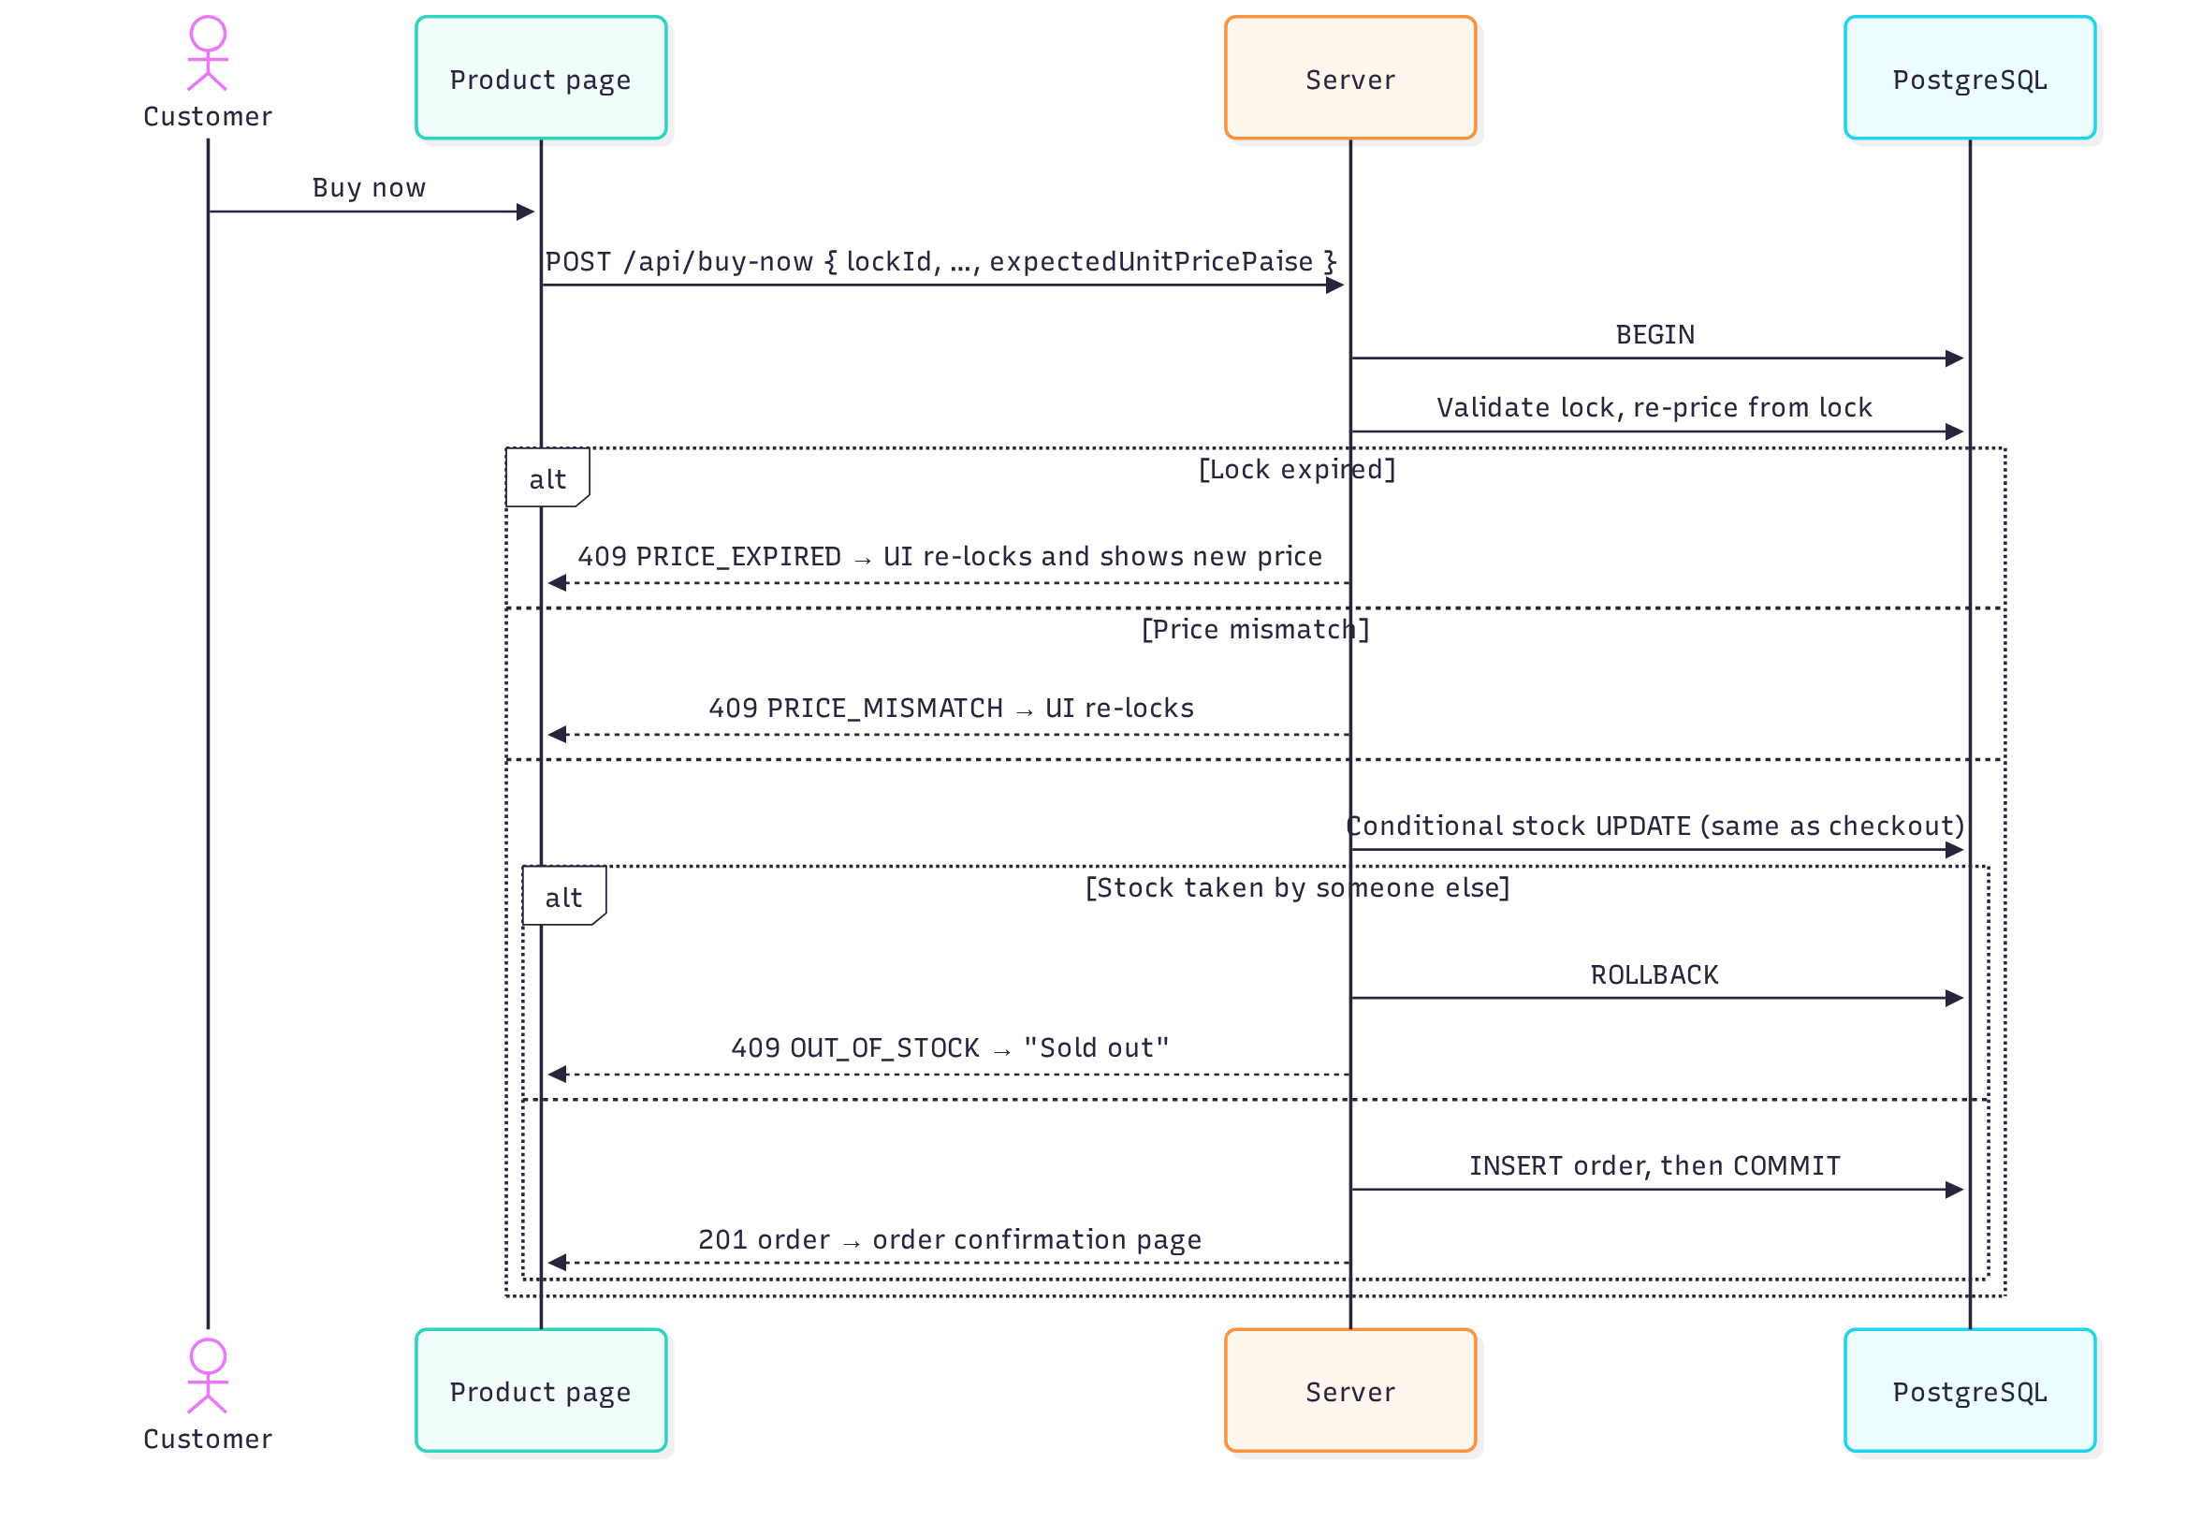

3.6 Two customers, last unit
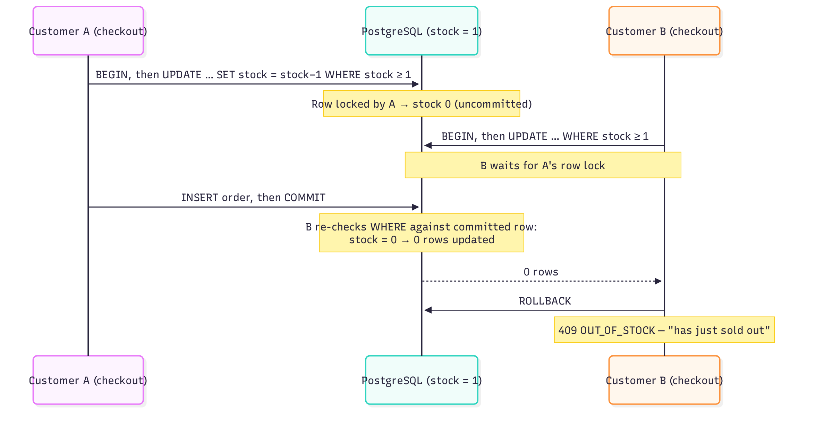

3.7 Live rates
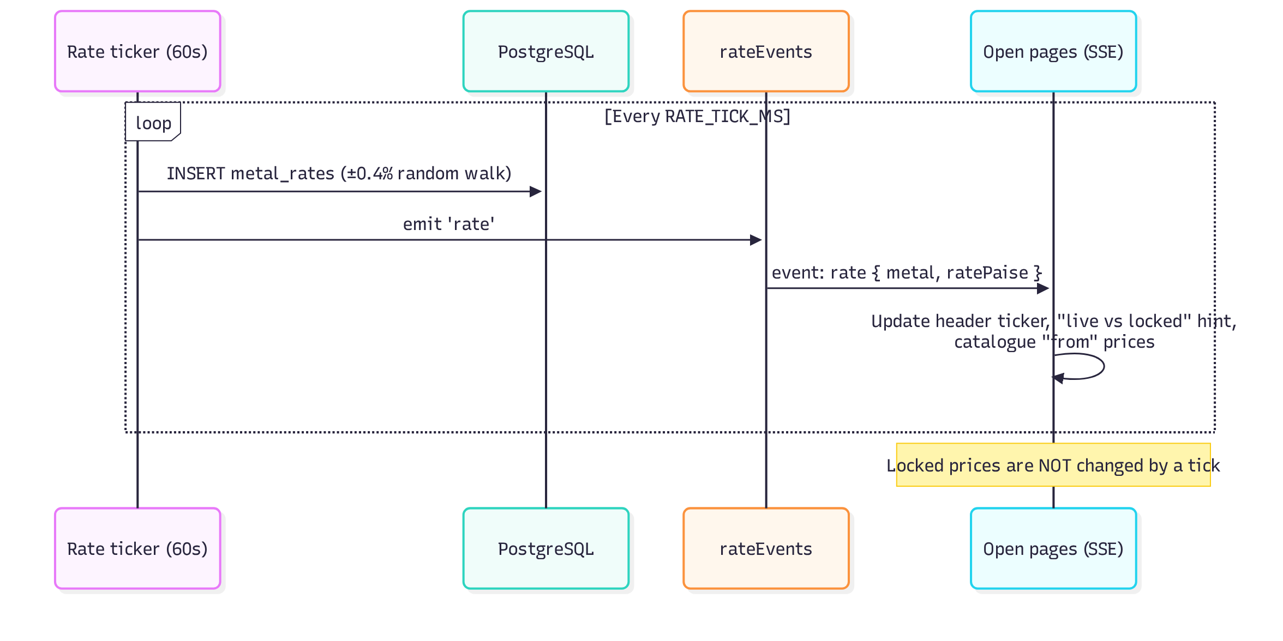

4. Cart item states
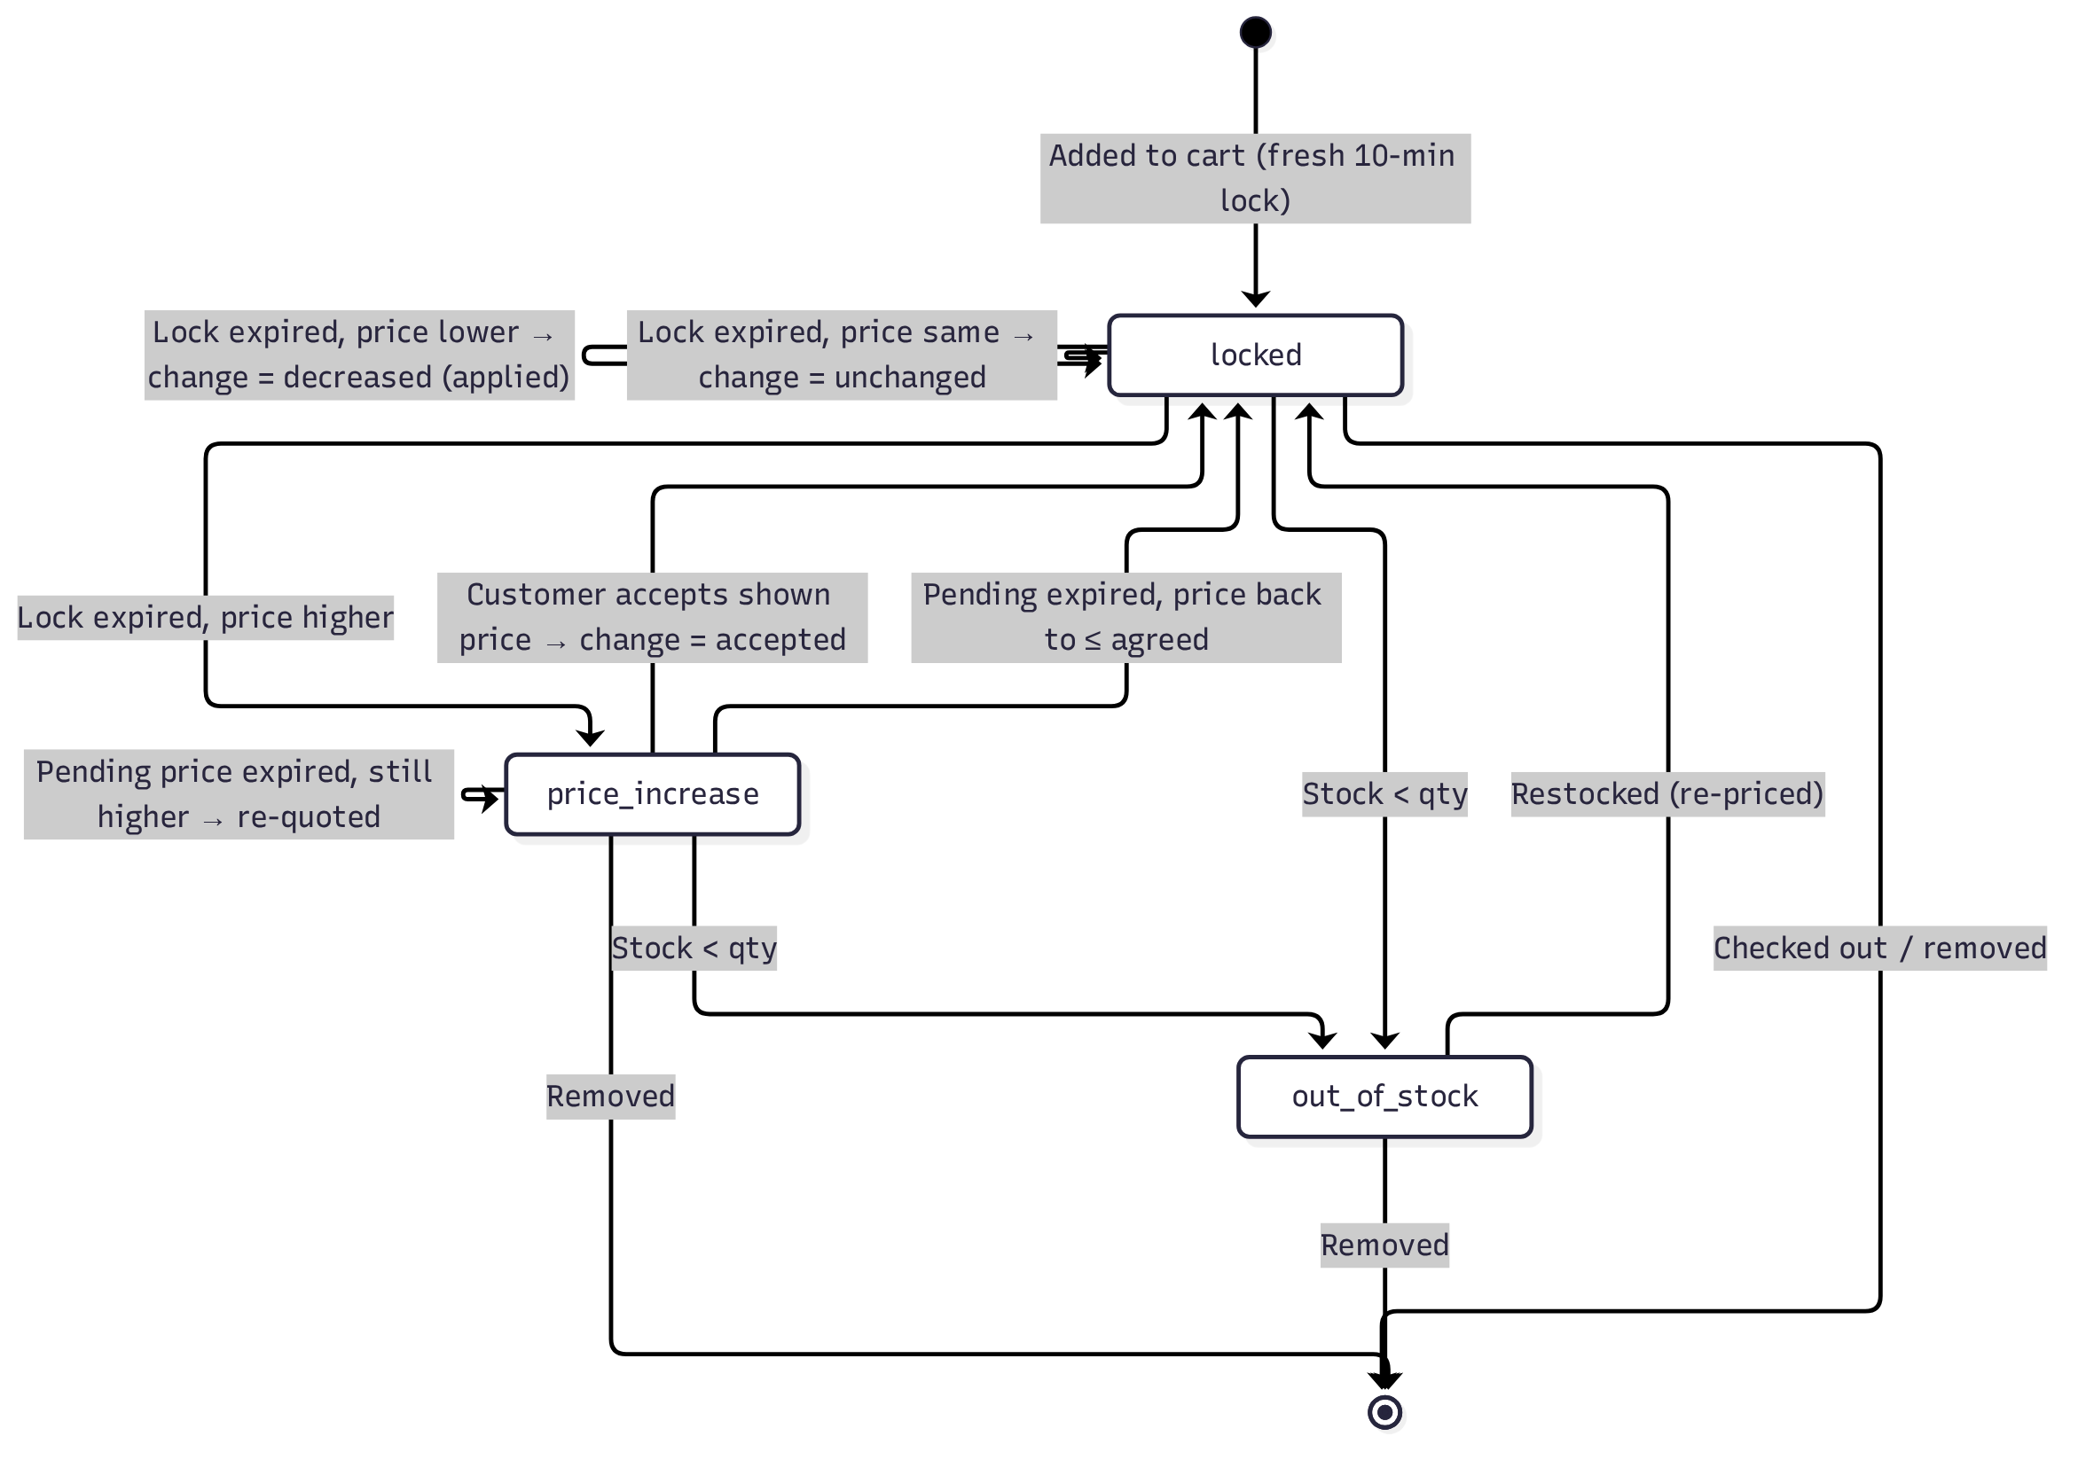
status | Meaning | Can checkout?
locked | Customer has agreed a price; lock running | Yes (if lock not expired)
price_increase | A higher price is waiting for the customer to accept | No
out_of_stock | Not enough stock for this item | No

change (note shown) | Meaning
null | No re-pricing has happened yet
decreased | Price fell; lower price applied automatically
unchanged | Price re-checked; same
increased | Price rose; awaiting acceptance
accepted | Customer accepted a higher price

5. Data model
File: server/src/schema.sql
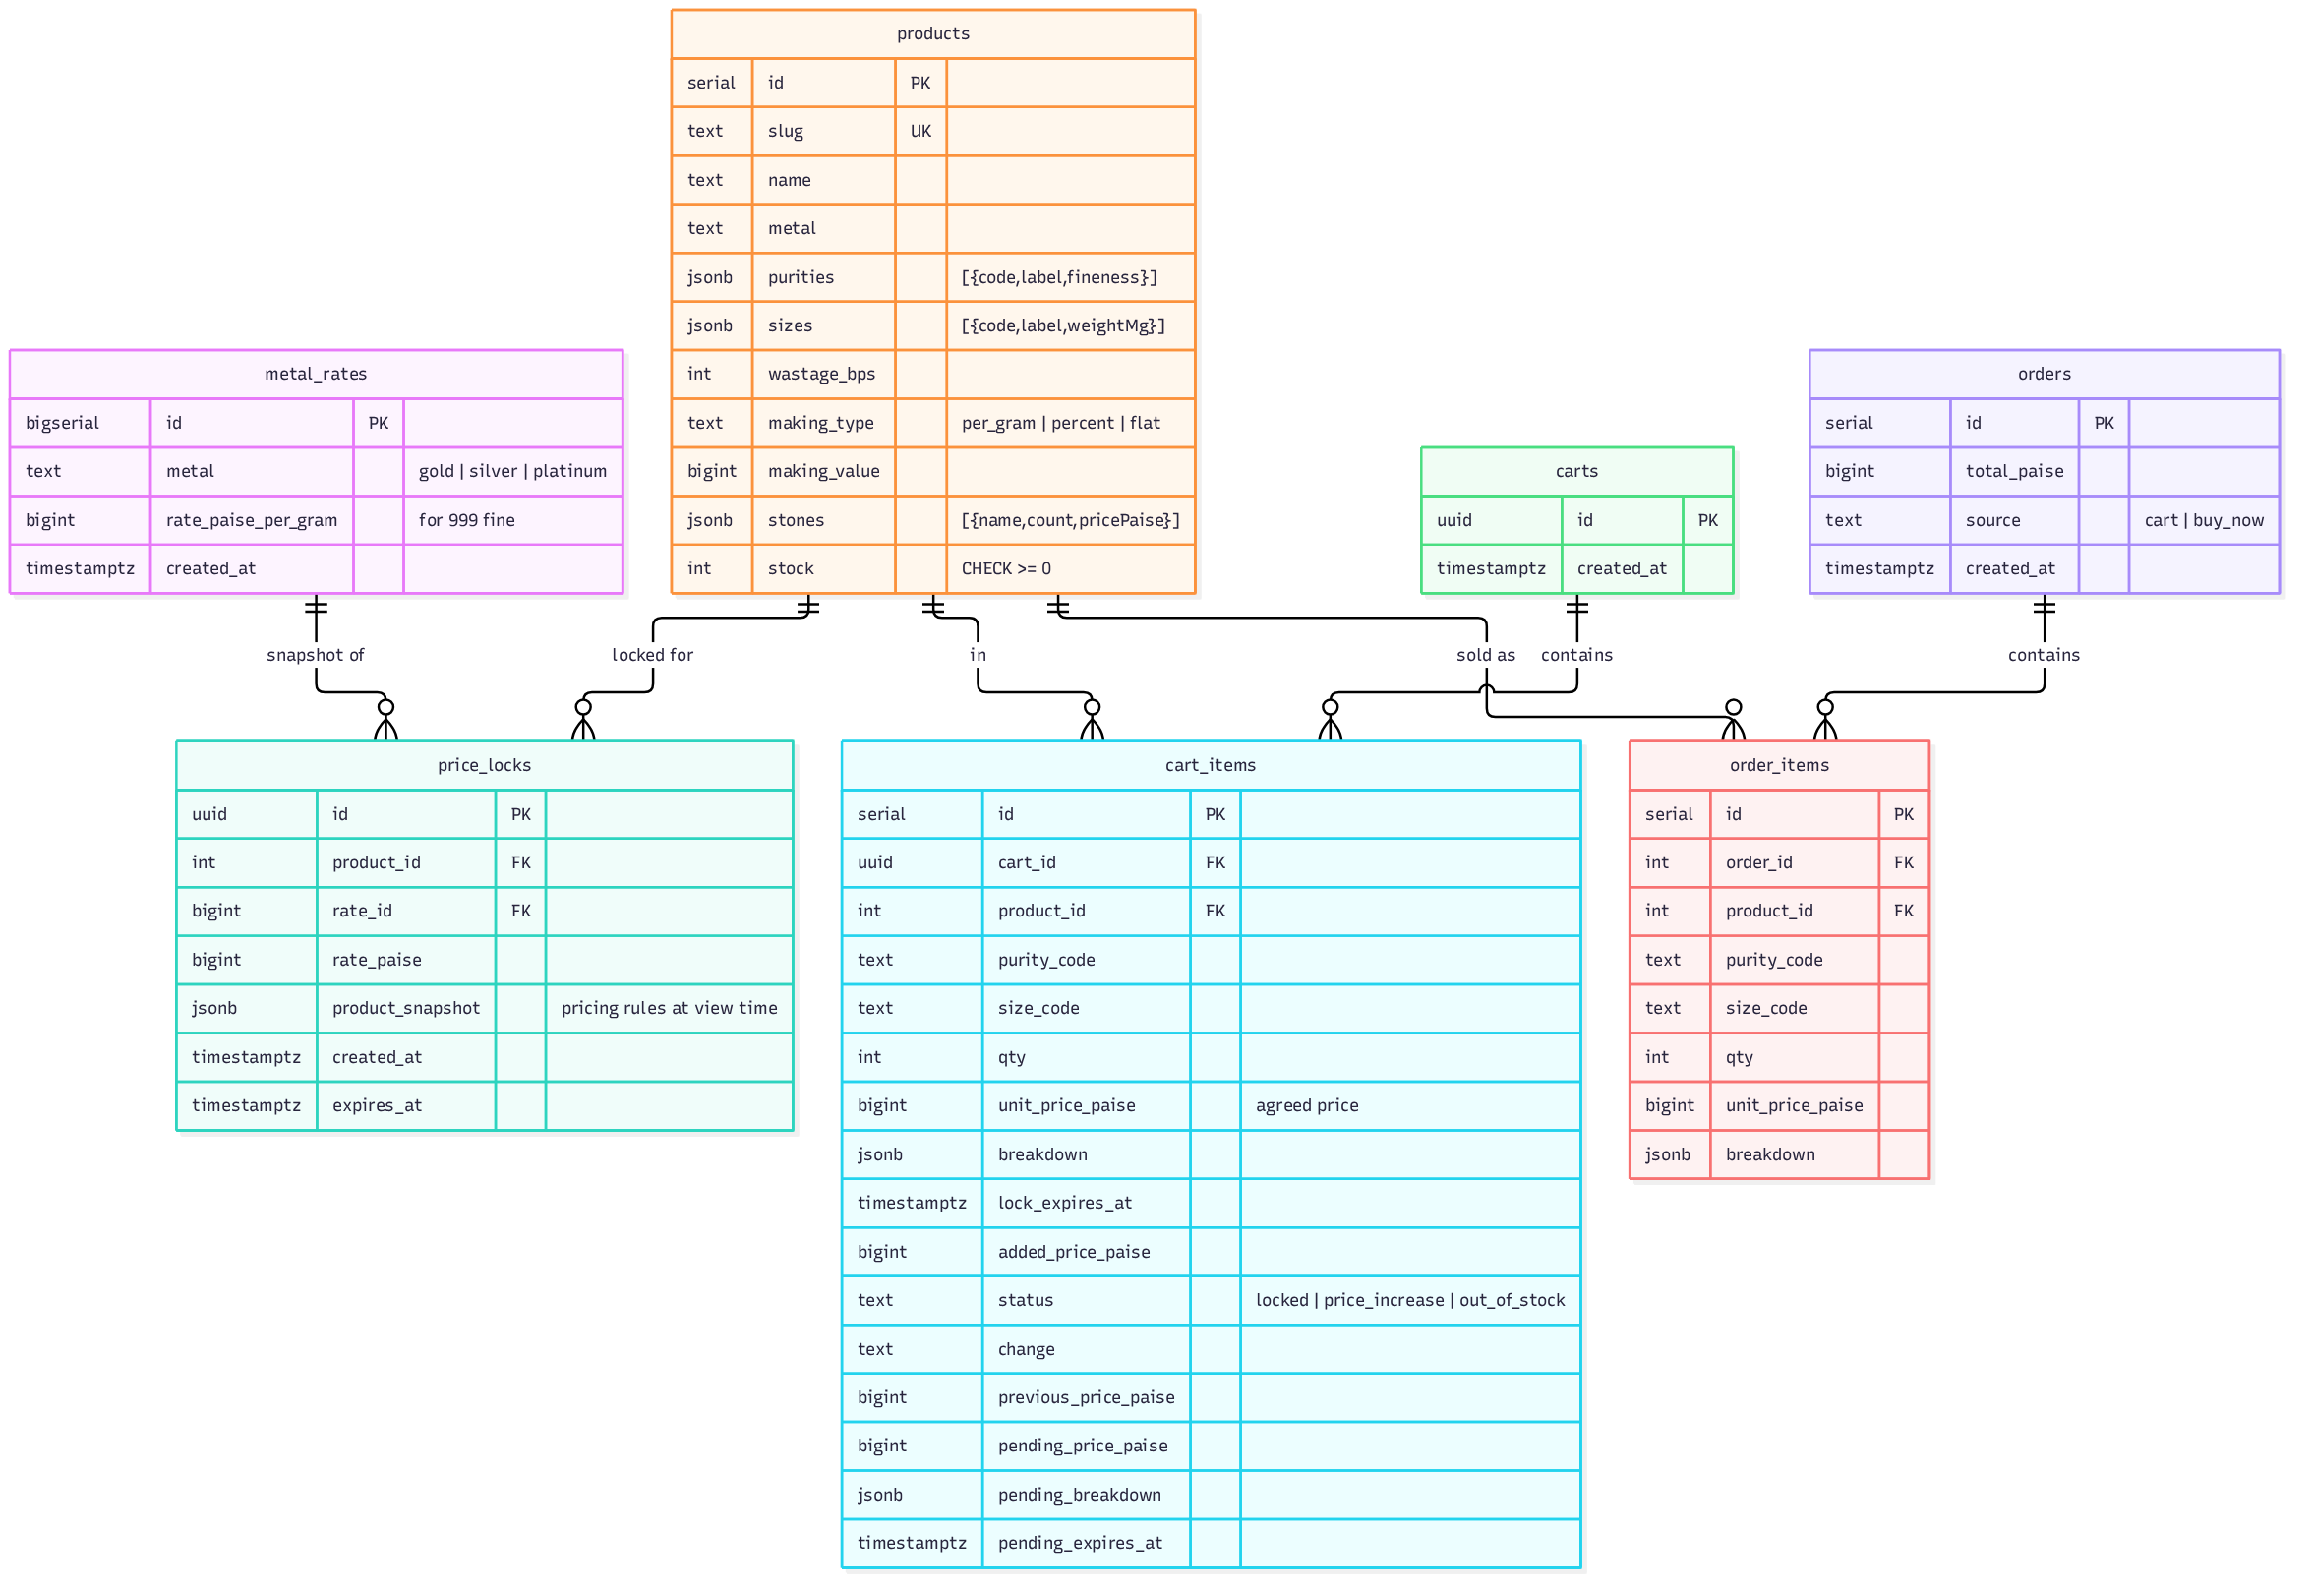
Notes:
- The latest row per metal in metal_rates is the live rate; history is kept.
- Every order item stores the full breakdown it was sold at.
- The schema is idempotent (CREATE … IF NOT EXISTS) and applied on every start. Seed data is inserted only when products is empty.

6. API reference
Base URL: http://localhost:3000/api · JSON in, JSON out · all money in paise.

Summary
Method | Path | Purpose
GET | /health | Health check
GET | /rates | Current rate for each metal
GET | /rates/stream | Live rate changes (Server-Sent Events)
GET | /products | All products, with live "from" price
GET | /products/:idOrSlug | One product
POST | /products/:idOrSlug/lock | Take a 10-minute price lock (called when a product is viewed)
POST | /buy-now | Buy one configuration straight from a lock
GET | /carts/:cartId | Get cart (re-prices expired items first)
POST | /carts/:cartId/items | Add an item from a lock
DELETE | /carts/:cartId/items/:itemId | Remove an item
POST | /carts/:cartId/items/:itemId/accept | Accept a price increase
POST | /carts/:cartId/checkout | Place an order for the whole cart
GET | /orders/:id | Order details
PUT | /admin/rates/:metal | (admin) Set a metal rate
PUT | /admin/products/:id/pricing-rules | (admin) Change wastage / making rules

GET /health
{ "ok": true }

GET /rates
{
"gold": { "id": 12, "ratePaise": 1245000, "updatedAt": "2026-10-21T11:40:00.000Z" },
"silver": { "id": 13, "ratePaise": 15200, "updatedAt": "…" },
"platinum": { "id": 14, "ratePaise": 495000, "updatedAt": "…" }
}

GET /rates/stream
Content-Type: text/event-stream. One event per rate change; a comment ping every 25 s.
event: rate
data: {"metal":"gold","ratePaise":1249980,"id":15,"at":"2026-10-21T11:41:00.000Z"}

GET /products
Array of products, each with fromPricePaise (cheapest purity at the smallest size, at the live rate).
[{
"id": 1, "slug": "aarna-solitaire-ring", "name": "Aarna Solitaire Ring",
"description": "…", "category": "ring", "metal": "gold",
"purities": [{ "code": "22K", "label": "22K (916)", "fineness": 916 }, { "code": "18K", "label": "18K (750)", "fineness": 750 }],
"sizes": [{ "code": "10", "label": "Size 10", "weightMg": 3850 }, …],
"wastageBps": 1000, "makingType": "per_gram", "makingValue": 65000,
"stones": [{ "name": "Diamond 0.25 ct (VS-GH)", "count": 1, "pricePaise": 3850000 }, …],
"stock": 3,
"fromPricePaise": 8393100
}]

GET /products/:idOrSlug
Same product shape, without fromPricePaise. 404 NOT_FOUND if missing.

POST /products/:idOrSlug/lock
No body. Returns 201:
{
"lock": {
"id": "91728397-054e-4127-a713-369d390f3fd2",
"productId": 1,
"ratePaise": 1245000,
"product": { "…pricing rules snapshot…" },
"createdAt": "2026-10-21T11:40:00.000Z",
"expiresAt": "2026-10-21T11:50:00.000Z"
},
"product": { "…live product incl. stock…" },
"serverTime": "2026-10-21T11:40:00.000Z"
}
The client computes the breakdown itself with priceProduct(lock.product, cfg, lock.ratePaise), and uses serverTime to correct its countdown for clock skew.

POST /buy-now
{
"lockId": "91728397-…",
"productId": 1,
"purityCode": "22K",
"sizeCode": "12",
"qty": 1,
"expectedUnitPricePaise": 9771626
}
201:
{ "id": 7, "totalPaise": 9771626, "createdAt": "…", "source": "buy_now" }
Errors: 409 PRICE_EXPIRED, 409 PRICE_MISMATCH, 409 OUT_OF_STOCK, 400 BAD_REQUEST.

GET /carts/:cartId
cartId is a UUID generated by the client. An unknown id returns an empty cart. Expired items are re-priced before responding.
{
"id": "5b3c…",
"items": [{
"id": 4,
"product": { "id": 1, "slug": "aarna-solitaire-ring", "name": "Aarna Solitaire Ring", "metal": "gold", "category": "ring" },
"stock": 3,
"purityCode": "18K", "sizeCode": "10",
"purityLabel": "18K (750)", "sizeLabel": "Size 10",
"qty": 1,
"status": "price_increase",
"change": "increased",
"addedPricePaise": 8375168,
"unitPricePaise": 8375168,
"linePaise": 8375168,
"breakdown": { "metalPaise": 3582710, "wastagePaise": 358271, "makingPaise": 250250, "stonesPaise": 3940000,
"subtotalPaise": 8131231, "gstPaise": 243937, "totalPaise": 8375168, "…": "…" },
"lockExpiresAt": "…",
"previousPricePaise": 8375168,
"pendingPricePaise": 8672328,
"pendingBreakdown": { "…": "…" },
"pendingExpiresAt": "…"
}],
"summary": {
"itemCount": 1,
"confirmedCount": 0,
"awaitingConfirmationCount": 1,
"outOfStockCount": 0,
"totalPaise": 0,
"totalIfAcceptedPaise": 8672328,
"canCheckout": false
},
"serverTime": "…"
}
summary.totalPaise counts confirmed items only; totalIfAcceptedPaise shows what the total would be if every pending increase were accepted.

POST /carts/:cartId/items
Body is the same as /buy-now. Starts a fresh 10-minute lock for the item. Returns 201 with the full cart. Errors: 409 PRICE_EXPIRED, 409 PRICE_MISMATCH, 409 OUT_OF_STOCK, 400 BAD_REQUEST.

DELETE /carts/:cartId/items/:itemId
Returns the updated cart.

POST /carts/:cartId/items/:itemId/accept
{ "pendingPricePaise": 8672328 }
Must equal the price the customer was shown. Returns the updated cart (item now locked, change: "accepted", fresh lock). Errors: 409 PRICE_CHANGED_AGAIN (with cart) if the pending price was re-quoted in the meantime; 404 NOT_FOUND.

POST /carts/:cartId/checkout
{ "expectedTotalPaise": 59960960 }
201:
{ "id": 8, "totalPaise": 59960960, "createdAt": "…", "source": "cart" }
Errors (each includes the refreshed cart): 409 CART_NEEDS_CONFIRMATION, 409 PRICE_MISMATCH, 409 OUT_OF_STOCK. Also 400 EMPTY_CART.

GET /orders/:id
{
"id": 8, "totalPaise": 59960960, "source": "cart", "createdAt": "…",
"items": [{ "productId": 1, "name": "Aarna Solitaire Ring", "slug": "…", "metal": "gold", "category": "ring",
"qty": 1, "unitPricePaise": 8672328, "breakdown": { "…": "…" } }]
}

PUT /admin/rates/:metal (admin)
Header x-admin-token: <ADMIN_TOKEN> (default admin).
{ "ratePaise": 1300000 }
Inserts a new rate and pushes it to all open pages. Returns { metal, ratePaise, id, at }.

PUT /admin/products/:id/pricing-rules (admin)
Header x-admin-token.
{ "wastageBps": 1000, "makingType": "per_gram", "makingValue": 65000 }
makingValue is paise per gram (per_gram), basis points (percent) or paise (flat). Applies to new locks and to cart items when re-priced; never to an existing lock. Returns the updated product.

7. Error codes
All errors share one shape:
{ "error": { "code": "OUT_OF_STOCK", "message": "Sorry, Meher Temple Necklace has just sold out.", "…extra": "…" } }
HTTP | Code | When | Client behaviour
400 | BAD_REQUEST | Invalid input (bad cart id, unknown purity/size, bad qty) | Show message
400 | EMPTY_CART | Checkout with no items | Show message
401 | UNAUTHORISED | Admin call without valid token | Show message
404 | NOT_FOUND | Product, item or order missing | Show message
409 | PRICE_EXPIRED | Lock has run out | Take a new lock and show the price change
409 | PRICE_MISMATCH | Browser's price/total ≠ server's | Re-lock (product) / show refreshed cart
409 | OUT_OF_STOCK | Not enough stock | Mark sold out
409 | CART_NEEDS_CONFIRMATION | Checkout with an expired, pending or out-of-stock item | Show refreshed cart with inline messages
409 | PRICE_CHANGED_AGAIN | Accept sent for a price that is no longer pending | Show refreshed cart
500 | INTERNAL | Unexpected error | Generic message; details in server log

8. Concurrency and safety
Risk | Protection
Two buyers, last unit | Single conditional UPDATE … WHERE stock >= qty; Postgres row lock makes the second wait and then see 0 rows
Stock going negative | CHECK (stock >= 0) on products as a backstop
Deadlock between multi-item carts | Products are decremented in ascending id order
Same cart checked out twice (double-click) | SELECT … FOR UPDATE on cart rows; second request finds the cart empty
Charging a price the customer didn't see | Server re-prices; checkout requires expectedTotalPaise to match; accept requires the shown pending price
Expired lock at checkout | Checked inside the checkout transaction; refused with the refreshed cart
Admin change during a lock | Lock stores a snapshot of the pricing rules
Client clock wrong | Countdown uses serverTime to correct skew; server is the only judge of expiry
Floating-point errors | Integer paise / mg / bps with BigInt intermediates
Isolation level is PostgreSQL's default READ COMMITTED, which is sufficient because the stock check and decrement happen in one atomic statement.

9. Front-end
Files: client/src/
File | Role
main.jsx | App shell, routes, header with cart badge and live-rate ticker
api.js | Fetch wrapper, ApiError, cart id in localStorage, clock-skew helper
hooks.js | useCountdown, useLiveRates (SSE), cart badge context
components.jsx | PriceBreakdown, LockTimer, JewelArt (SVG illustrations), Money
pages/Catalog.jsx | Product grid with live "from" prices
pages/Product.jsx | Configurator, lock + countdown, re-lock on expiry, accept flow, Add to cart / Buy now
pages/Cart.jsx | Items with own countdowns, inline messages, accept/remove, summary, gated checkout
pages/Order.jsx | Order confirmation
pages/Admin.jsx | Set rates; edit wastage/making rules
Routes: /, /products/:slug, /cart, /orders/:id, /admin.
Responsive breakpoints: 860 px (stack to single column) and 520 px (phone layout).

10. Tests
Folder: server/test/ · runner: Node's built-in node:test · real PostgreSQL (separate jewellery_test database).
File | Tests | Covers
pricing.test.js | 8 | Hand-calculated prices (gold/silver/platinum, all making types, stones), half-up rounding, breakdown always sums to total
price-lock.test.js | 6 | 9:59 valid / 10:00 expired; locked price holds when rate or admin rules change; expired Buy-now / Add-to-cart refused and take no stock; mismatched client price refused
concurrent-checkout.test.js | 5 | Two carts race for last unit (once and 20×); 15 Buy-nows for 3 units; cart vs Buy-now; double-clicked checkout
cart-price-change.test.js | 10 | Over HTTP: drop applied, unchanged, rise blocks checkout until accepted, stale accept refused, pending re-quoted, out of stock, expired-lock checkout, summary counts
Time is controlled through an injectable clock (server/src/clock.js), so lock expiry is tested instantly without sleeping.

